EDUCATIONAL ORGANIZATION USING SERVICENOW
Date | 27-01-2026
Team ID | LTVIP2026TMIDS24916
Project Name | Educational Organization Using ServiceNow
Maximum Marks | 4 Marks

Step-1:Team Gathering,Collaboration &Select the Problem Statement
The project titled “Educational Organization using ServiceNow” began with the formation of our project team. Our team members came together with a shared interest in exploring cloud-based automation tools and their applications in the education sector. During the initial gathering sessions, we discussed various challenges faced by educational institutions in managing administrative, academic, and support processes.
Through collaboration meetings and brainstorming sessions, we analyzed different problem areas such as student record management, faculty request handling, IT service management, and workflow automation in academic environments. Each member contributed ideas and research insights to identify the most feasible and impactful area of focus.
After evaluating multiple topics, we collectively decided to develop a ServiceNow-based Educational Organization Management System.
Step-2:Idea Listing and Grouping
After finalizing our project team and identifying our general area of interest, we moved to the next phase — Idea Listing and Grouping. In this stage, our team conducted brainstorming sessions to generate and organize different ideas related to the use of ServiceNow in the educational domain.
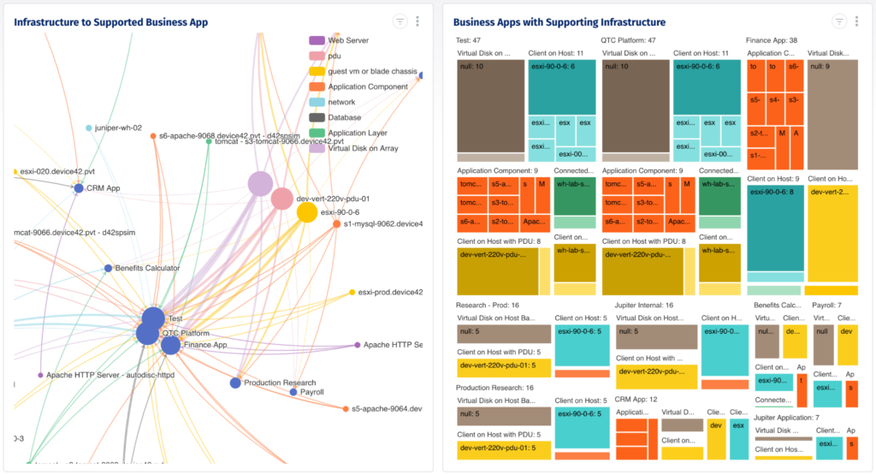
Step-3:Idea Prioritization


